**2025 Booking a Parent Interview**

Click on link to access interviews: <https://victoriaparkss.schoolzineplus.com/interviews>

**Step 1- Select Student.** Click Add New Student and fill in Student Details then save. Select Student, click save and continue.

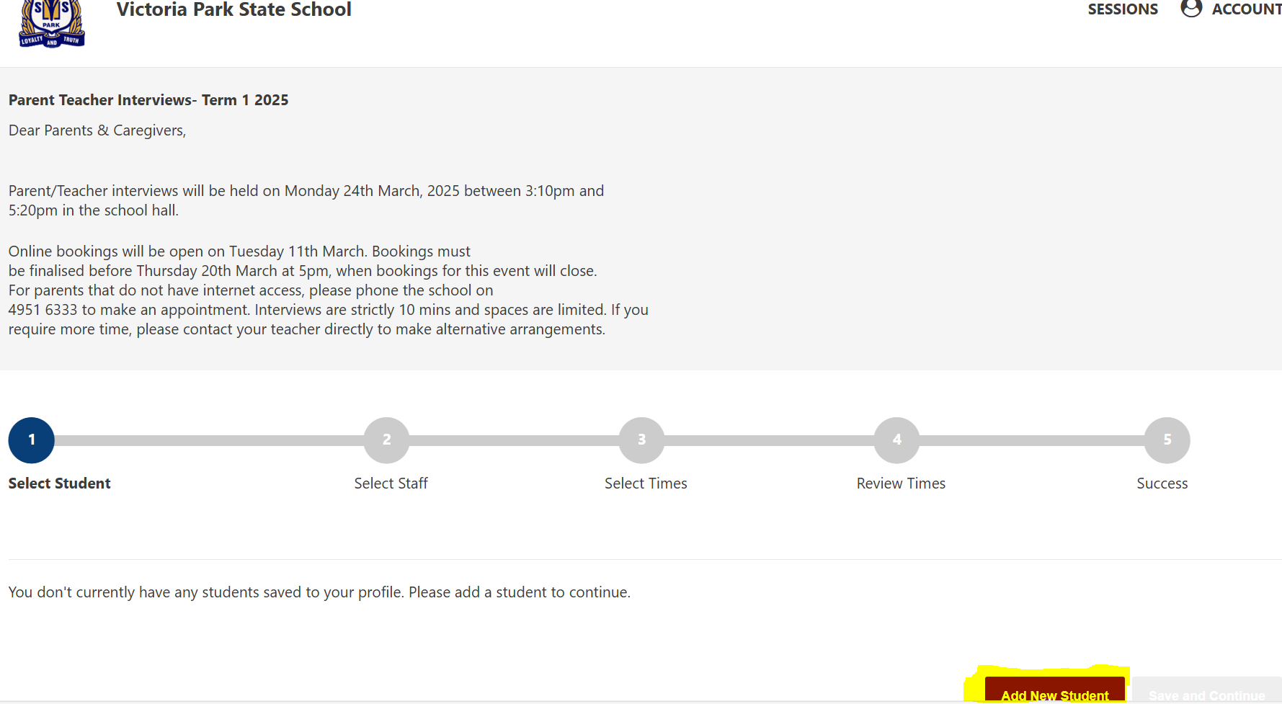

**Step 2:- Select Class Teacher**, Scroll down and click Next

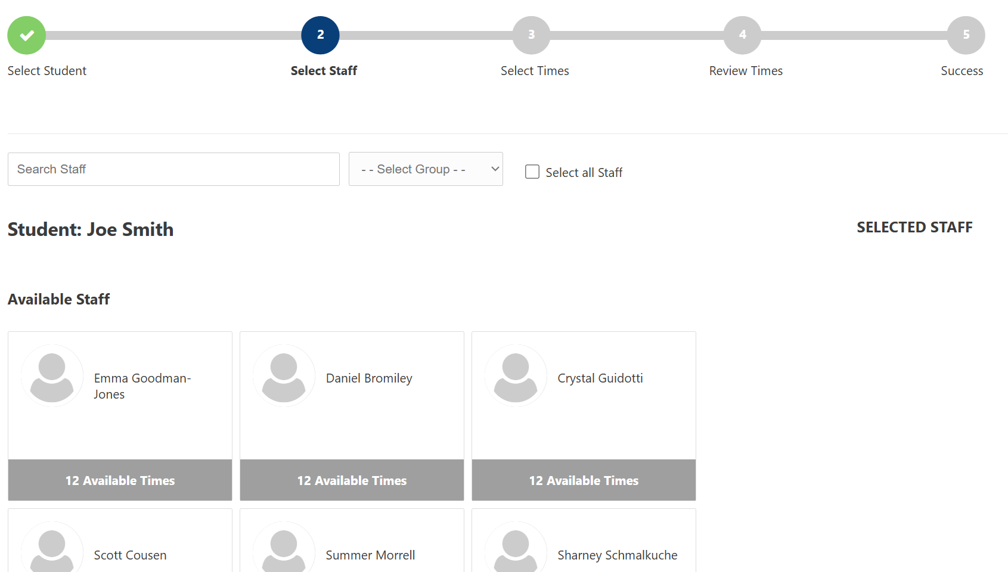

**Step 3- Select Interview time and add parent/carer details**

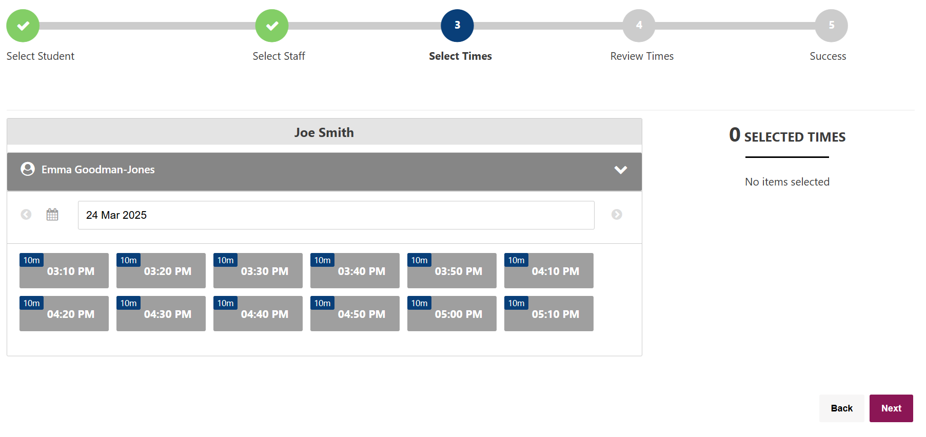 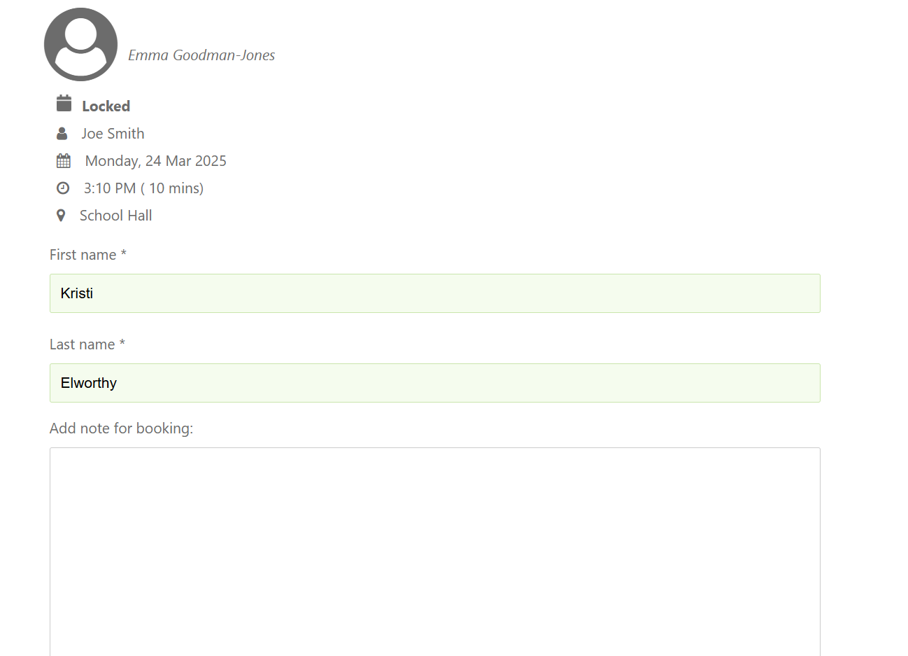

**Step 4- Review your booking. You will receive a confirmation email**